Terraform resource output

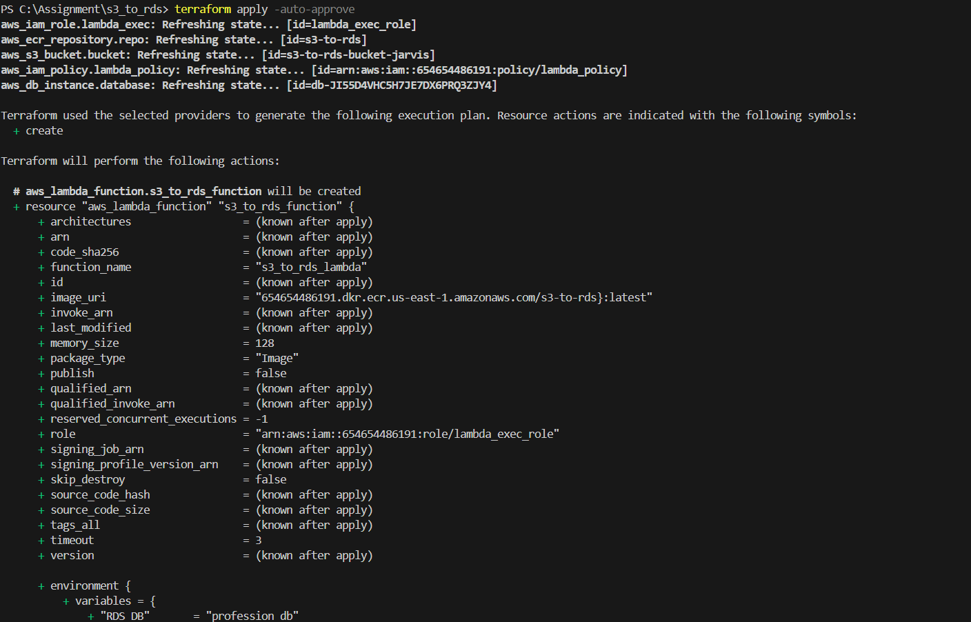

Docker Image build

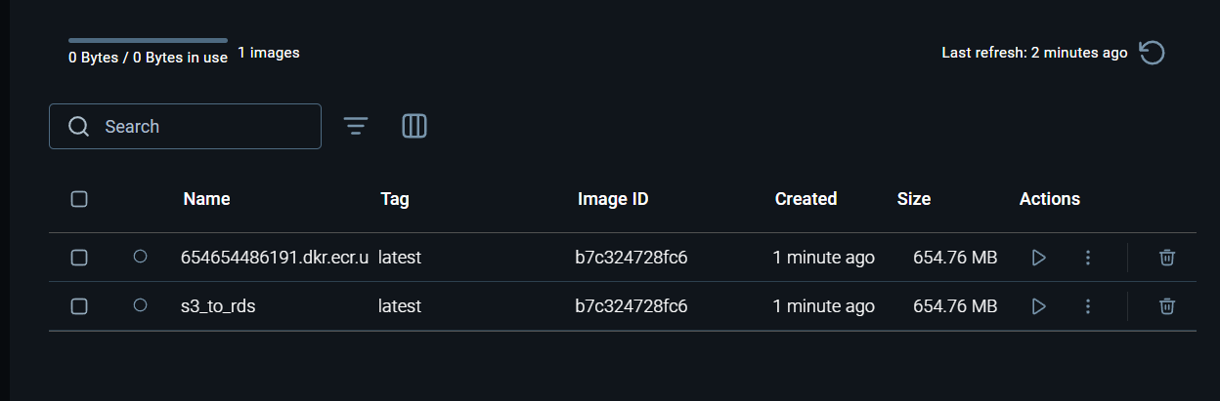

I couldn’t complete assignment because I was not able to upload the docker image to ECR for lambda function to access it.